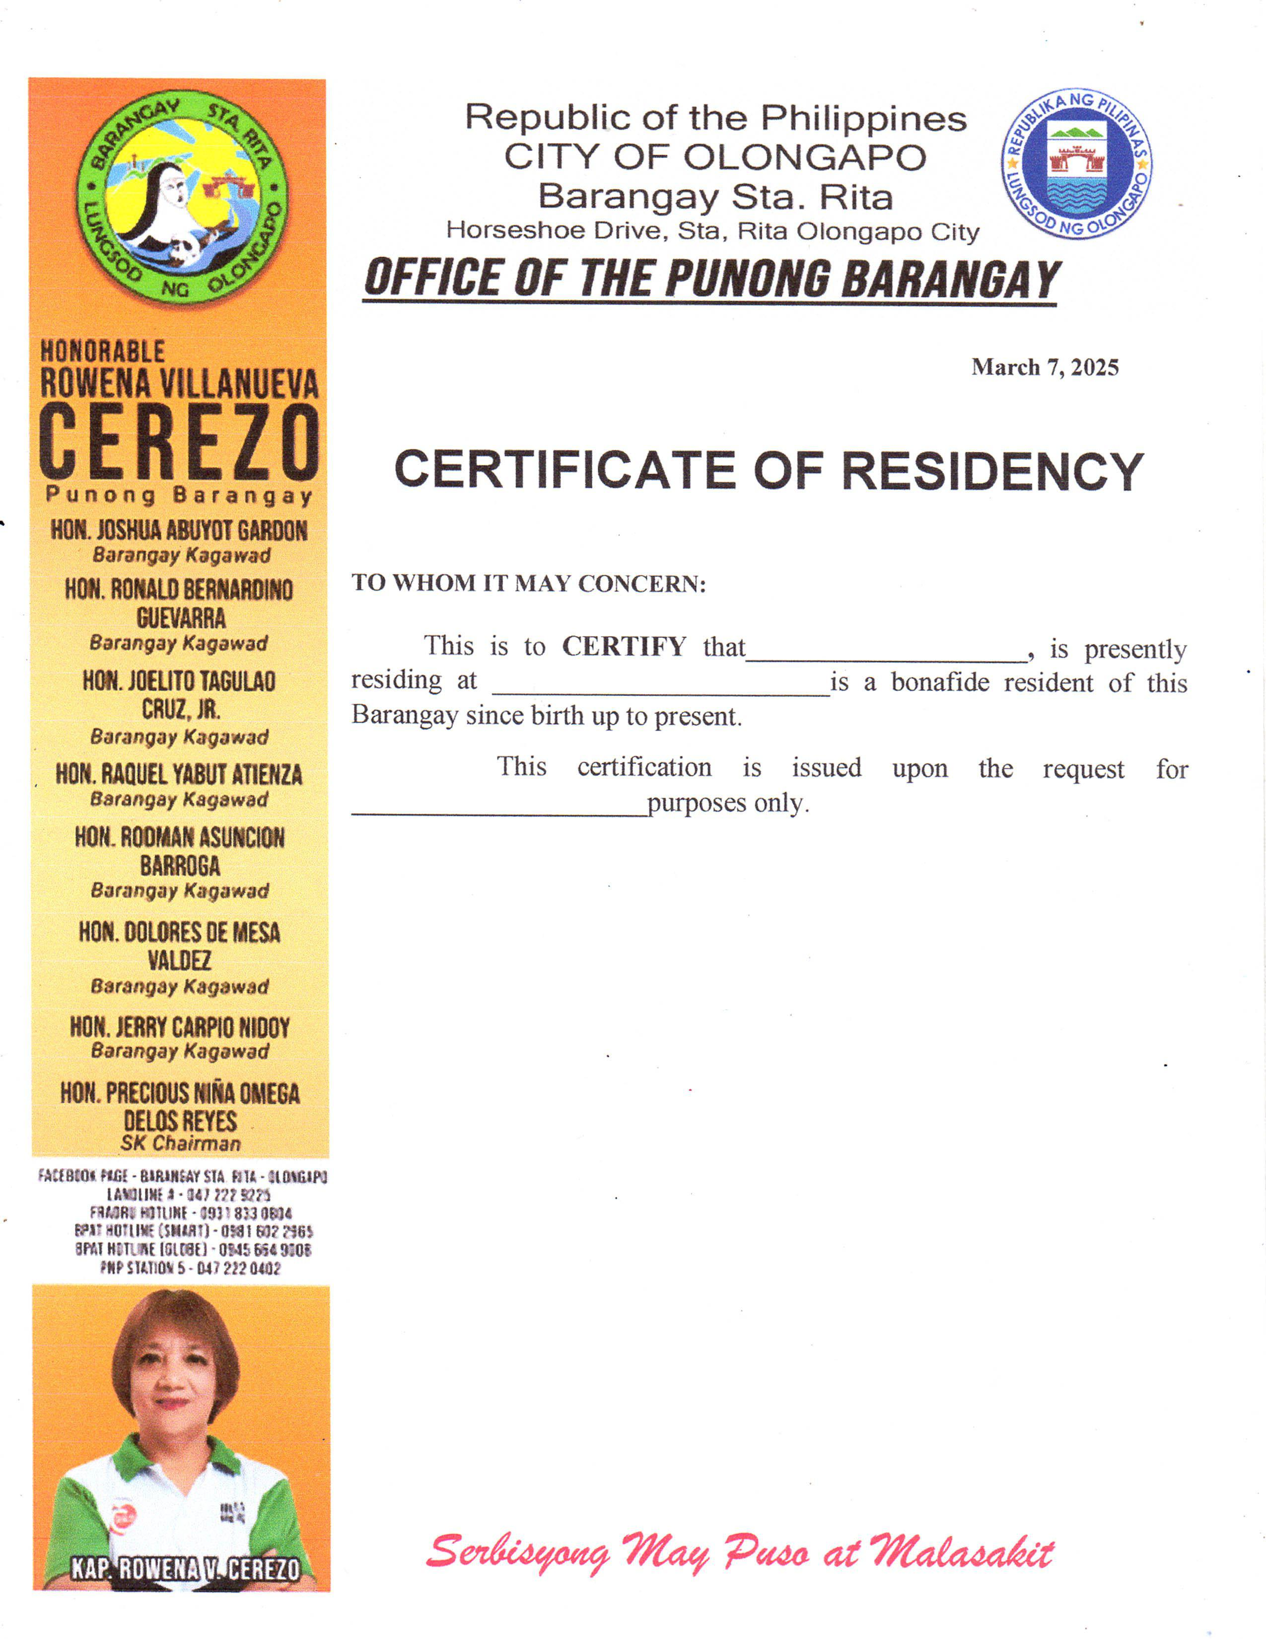 Republic of the Philippines CITY OF OLONGAPO Barangay Sta. Rita Horseshoe Drive, Sta. Rita Olongapo City ***OFFICE OF THE PUNONG BARANGAY***

**March 7, 2025**

CERTIFICATE OF RESIDENCY

**TO WHOM IT MAY CONCERN:**

This is to **CERTIFY** that___________________, is presently residing at ________________________ is a bonafide resident of this Barangay since birth up to present.

 This certification is issued upon the request for ______________________ purposes only.